**Lab 2 Report Guide**

Author: Yuechuan Lin

Date: June 14, 2019

**INTRODUCTION**

Vp141 is known to be a tough course in Joint Institute. This guide aims to show the students what is expected in professional or technical reports to accelerate the learning process. Students who read this guide are expected to get a higher report grade and have a better understanding of what is a good report.

**THEORETICAL BACKGROUND**

The grading formula for Vp141 is

$$G=G_{r}+G_{q}+G_{q}$$

(1)

where $G$ is the total grade (maximum: 100), $G_{r}$ is the grade for the report (maximum: 50), $G_{q}$ is the grade for the quiz (maximum: 15), $G_{q}$ is the grade for lab work (maximum: 35). In order to maximize the grade, $G_{r}$, $G_{q}$ and $G_{q}$ need to be maximized.

**PROCEDURE**

**Apparatus**

In order to prepare this guide that will accelerate the learning process, a junior JI student, as shown in Figure 1, was used to write and revise the guide. This student just survived from two lab courses in U of M (ME 395 and PHYSICS 391). The typing rate of this junior JI student is 40 words per minute with 10% wrong words and the grammar and vocabulary of this junior student is poor.

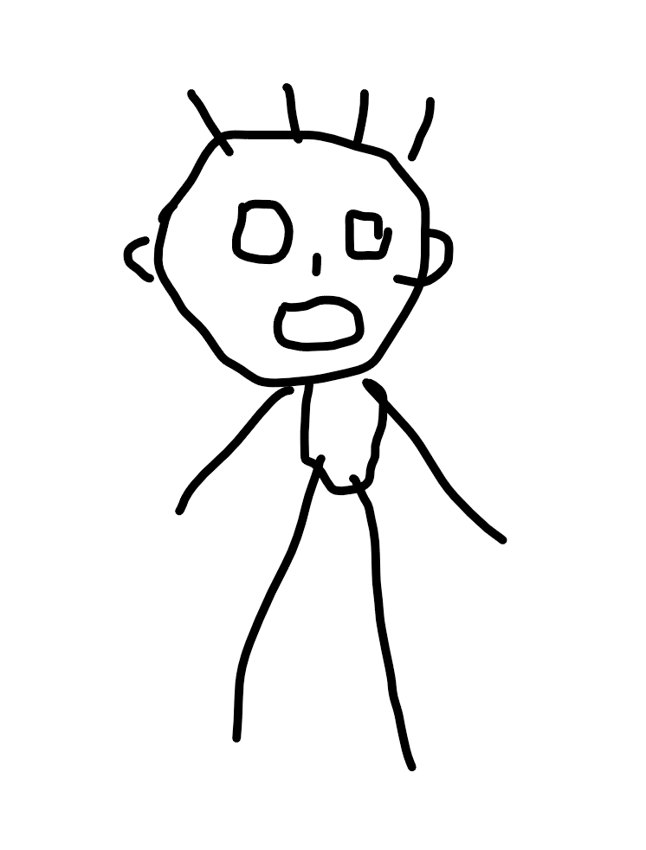

Figure 1. Sketch of the author

**RESULT AND DISCUSSION**

In order to make the learning process more efficient, several pieces of advice about writing a physics lab report are collected.

**Structure of the report**

The structure of the report can be in any forms whichever contains the contents of introduction, theory, apparatus, procedure, result, discussion and conclusion. Students have the freedom to change the structure in order to have a better “flow” of writing.

**Tense**

First person tense should be avoided because the focus of the report should always be put on the subject, not the author. For example,

“In order to make the learning process more efficient, I write this guide to show you what is expected in professional or technical reports.”

This sentence should be modified as

“This guide aims to show the students what is expected in professional or technical reports to accelerate the learning process.”

The emphasis is shifted from “I” to the guide itself by changing the tense which is favorable for a scientific report since it aims to describe the experiment objectively.

**Essence of procedure**

The procedure is not a manual! A manual serves as a step-by-step guide to lead the student through the experiment, while procedure aims at showing the key steps that will influence the result. For example, making the platform of the apparatus horizontal is important, while open the power source of the laser beam is trivial.

**Intermediate results**

Intermediate results are necessary to give credibility to the report. For example, in lab 2 the velocity of the ball falling at steady-state is an important intermediate result. On the other hand, trivial derivation of intermediate results, like taking the average of multiple measurements, disturbs the flow of reading. The intermediate results are like stairs to the final result, if the stairs are too steep readers will be skeptical about the result if the stairs are too small readers will feel boring and disturbing.

**Assumptions**

Experimenters don’t guess, instead, they assume, when they confront the discrepancy between the ideal situation and real situation. For example, ideally the ball reached constant speed before crossing the laser beams, but the constant speed was not verified in the experiment, thus in order to evaluate the viscosity using the formula based on constant speed, an assumption should state that the ball was assumed to reach steady-state when it blocks the beams.

**Discussion**

The discussion is a section that discusses what’s the meaning of the result, what factors could lead to a potentially higher error (assumptions, procedures …), whether the result agrees with literature or common sense.

**Conclusion**

The conclusion briefly summarized the important results and related discussion. New ideas and thoughts should not appear in conclusion.

**Proof read**

Proof read helps to reduce the grammar and vocabulary error in the report.

**Length of the report**

The proper length of a report is determined by the complexity of the subject, not by the length of others report. Lab 2 is less complex compared with other labs. From previous experience, a 3-page-report about 900 words excluding the appendix can get a satisfactory feedback from the instructor. To save the earth, to save students’ time, to save the author’s time, the length of the report must be less than 8 pages and 2500 words, excluding the appendix and cover page. Students who manage to finish the report in 5 pages could get a bonus if the content of the report is complete.

**Uncertainty**

The uncertainty of the apparatus and tools should be clearly described in the procedure. Any measured value must be followed by corresponding uncertainty. The calculation of uncertainty must appear at the appendix. The calculation of uncertainty can be in forms of printed code or typed document. The format and style of the uncertainty calculation are not graded. The uncertainty calculation serves as proof of calculation.

**CONCLUSION**

This guide gives several pieces of advice on how to write a good report.

All work and no play makes Jack a dull boy

All work and no play makes Jack a dull boy

All work and no play makes Jack a dull boy